**Authentication & Authorization**

1. How would you explain the overall concept of Authentication and Authorization in Angular applications, and why are these important for application security?

Authentication and Authorization are crucial security aspects in Angular applications. Authentication verifies a user’s identity, ensuring they are who they claim to be, typically through credentials like username and password. Authorization determines the level of access granted to authenticated users, controlling which resources or actions they can perform.

These concepts are vital for application security as they prevent unauthorized access, protect sensitive data, and maintain system integrity. Implementing robust authentication and authorization mechanisms ensures only legitimate users can access specific functionalities, reducing potential vulnerabilities and risks.

Angular supports various libraries and techniques for implementing these features, such as JSON Web Tokens (JWT) for stateless authentication and role-based access control for granular authorization. Integrating these methods into an Angular application enhances its overall security posture and promotes best practices in web development.

#### 2. Can you describe the difference between Authentication and Authorization in the context of Angular?

In Angular, authentication is often implemented using JSON Web Tokens (JWT) that are sent from the server upon successful login. The token is stored client-side and included in subsequent requests to validate the user’s identity.

For authorization, Angular uses route guards to protect specific routes based on user roles or permissions. Route guards are services implementing the CanActivate or CanLoad interfaces, which determine if a user can access a particular route.

**import** { Injectable } from '@angular/core';

**import** { CanActivate, ActivatedRouteSnapshot, RouterStateSnapshot } from '@angular/router';

@Injectable({ providedIn: 'root' })

**export** **class** AdminGuard implements CanActivate {

**constructor**(**private** authService: AuthService) {}

canActivate(route: ActivatedRouteSnapshot, state: RouterStateSnapshot): **boolean** {

**return** **this**.authService.isAdmin();

}

}

#### 3. What are the various authentication mechanisms that can be used in Angular applications, and what are the pros and cons of each?

Angular applications support multiple authentication mechanisms, including:

1. Token-based (JWT): JSON Web Tokens are compact and self-contained tokens for securely transmitting information. Pros: Stateless, scalable, and mobile-friendly. Cons: Vulnerable to token theft and requires extra care in storage.

2. OAuth 2.0/OpenID Connect: Open standard protocols for authorization and identity management. Pros: Widely adopted, secure, and supports third-party integrations. Cons: Complex setup and may require additional server-side implementation.

3. Cookie-based: Traditional method using cookies to store session data. Pros: Simple and well-understood. Cons: Stateful, less suitable for modern single-page applications, and vulnerable to CSRF attacks.

4. SAML: Security Assertion Markup Language is an XML-based standard for exchanging authentication and authorization data. Pros: Supports Single Sign-On (SSO) and enterprise-level security. Cons: Verbose, complex, and not natively supported by Angular.

#### 4. What is JWT (JSON Web Token), and how does it work in Angular applications for authentication purposes?

JWT (JSON Web Token) is a compact, URL-safe means of representing claims to be transferred between parties. In Angular applications, JWTs are used for authentication purposes by encoding user information in a secure manner.

When a user logs in, the server validates their credentials and generates a JWT containing the user’s data (e.g., ID, role). The token is then signed using a secret key and sent back to the client. Angular stores this token, typically in local storage or an HttpOnly cookie, and attaches it as an Authorization header with each subsequent request to protected API endpoints.

The server verifies the token signature upon receiving requests, ensuring its integrity and authenticity. If valid, the server processes the request and sends the appropriate response. Expired or invalid tokens result in access denial, prompting re-authentication.

Using JWTs in Angular simplifies authentication management, reduces server load through stateless sessions, and enhances security via token encryption and expiration mechanisms.

#### 5. Can you provide an example of how to implement a secure HTTP interceptor in Angular to add JWT to the request headers?

To implement a secure HTTP interceptor in Angular for adding JWT to request headers, follow these steps:

1. Create an authentication service that handles token storage and retrieval.  
   2. Generate an interceptor class implementing HttpInterceptor.  
   3. In the intercept method, retrieve the JWT from the authentication service.  
   4. Clone the original HttpRequest object with modified headers containing the JWT.  
   5. Call next.handle() with the cloned request.

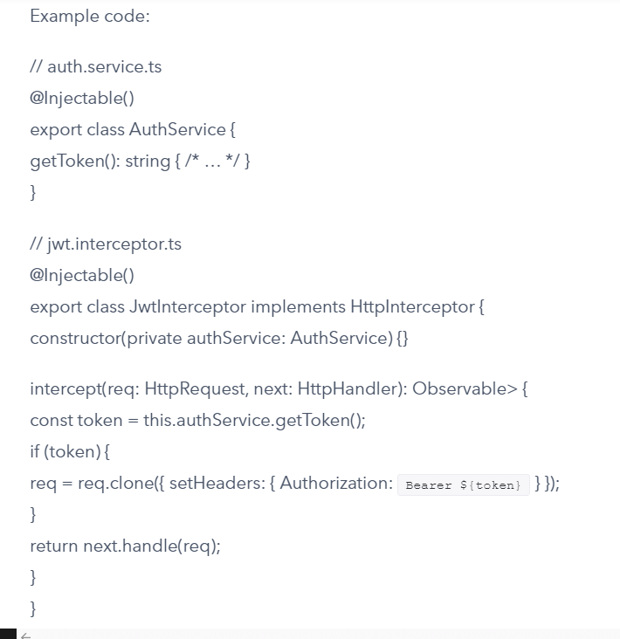

// app.module.ts  
@NgModule({  
providers: [  
{ provide: HTTP_INTERCEPTORS, useClass: JwtInterceptor, multi: true },  
],  
})  
export class AppModule {}

#### 6. In Angular, what factors should be considered when choosing between using cookies or local storage for storing authentication tokens?

#### 

#### 7. What is the role of route guards in Angular, and how can they be used to implement authorization?

#### Route guards in Angular are responsible for controlling access to specific routes based on user roles or permissions. They act as middleware, deciding whether a user can navigate to a particular route or not.

To implement authorization using route guards, follow these steps:

1. Create a custom guard by implementing the CanActivate interface.  
2. Inject any required services, such as an authentication service, into the guard’s constructor.  
3. Implement the canActivate() method, which returns either true (allowing navigation) or false (denying navigation). Use the injected services to determine if the user has the necessary permissions.  
4. Register the custom guard in the AppModule providers array.  
5. Add the custom guard to the desired route(s) in the AppRoutingModule using the ‘canActivate’ property.

#### 

#### 8. Can you explain the concept of Role-Based Access Control (RBAC) and how it can be implemented in Angular applications?

#### Role-Based Access Control (RBAC) is a security model that restricts access to resources based on user roles. In Angular applications, RBAC can be implemented using route guards and directives.

#### 1. Define roles: Create an enumeration or constants representing different user roles, e.g., Admin, User, Guest. 2. Assign roles to users: Store the role information in the user object after successful authentication. 3. Protect routes: Implement route guards like canActivate and canActivateChild to check if the user has the required role before allowing navigation. 4. Example of canActivate guard:

#### 

#### 

#### 9. How do you manage user sessions and handle session expiration in Angular applications?

#### In Angular applications, managing user sessions and handling session expiration involves using a combination of JWT tokens, HttpInterceptors, and route guards.

#### 

#### 12. How do you secure Angular applications against common security vulnerabilities like Cross-Site Scripting (XSS) and Cross-Site Request Forgery (CSRF) attacks?

To secure Angular applications against XSS and CSRF attacks, follow these steps:

1. Utilize Angular’s built-in protection: Angular automatically escapes potentially harmful characters in data bindings, preventing most XSS attacks.

2. Sanitize user input: Use the DomSanitizer service to sanitize untrusted HTML or CSS before inserting it into the DOM.

3. Implement Content Security Policy (CSP): Configure CSP headers on your server to restrict sources of scripts, styles, and other resources.

4. Prevent CSRF attacks: Use a CSRF token with each request that modifies data. Store the token in an HttpOnly cookie and include it as a custom header in requests.

5. Validate user permissions: Implement authorization checks on both client-side routes and server-side API endpoints to ensure users can only access allowed resources.

6. Keep dependencies up-to-date: Regularly update Angular and third-party libraries to apply security patches.

#### 13. Can you describe the process of securely implementing social login (e.g., Google, Facebook) in Angular applications?

#### 

#### 15. How do you implement Two-Factor Authentication (2FA) in Angular applications?

#### 

#### 

#### 16. What strategies and tools can be used for testing the security of Angular authentication and authorization implementations?

To test Angular authentication and authorization security, use the following strategies and tools:

1. Unit Testing: Employ Jasmine and Karma to create isolated tests for components, services, and guards related to authentication and authorization.

2. End-to-End Testing: Utilize Protractor or Cypress to simulate user interactions with the application, ensuring proper access control and secure data handling.

3. Static Analysis: Implement tools like ESLint or TSLint to identify potential security vulnerabilities in code, such as weak encryption algorithms or improper input validation.

4. Dependency Scanning: Use npm audit or Snyk to detect outdated or vulnerable dependencies that may compromise security.

5. Penetration Testing: Engage ethical hackers or automated tools like OWASP ZAP to simulate real-world attacks on the application, identifying weaknesses in authentication and authorization mechanisms.

6. Code Review: Conduct thorough reviews of code changes, focusing on areas related to security, to ensure adherence to best practices and prevent introducing vulnerabilities.

#### 19. Can you explain what is meant by “Stateless Authentication” in Angular and why it’s important?

Stateless authentication in Angular refers to an approach where the server doesn’t maintain user session information. Instead, it relies on tokens (e.g., JWT) sent by clients for each request. The token contains necessary data for authentication and authorization.

This method is important due to its scalability, as servers don’t need to store session data, reducing memory usage. It also simplifies load balancing since any server can handle requests without needing shared session storage. Stateless authentication enhances security, as tokens are short-lived and can be revoked easily if compromised.

#### 20. How do you handle password storage and encryption in Angular applications?

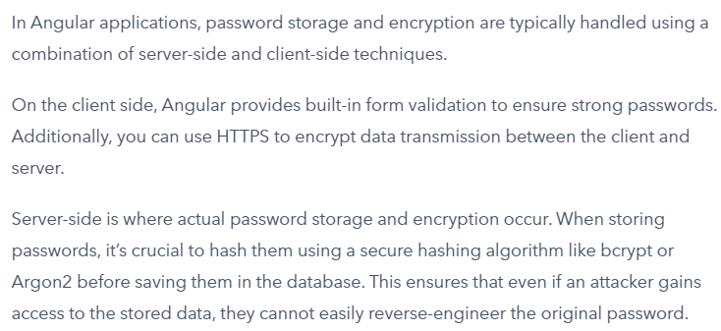

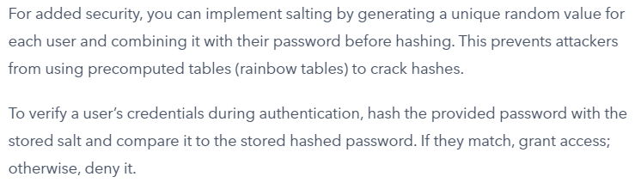

#### 23. What are some best practices for keeping Angular application tokens secure from theft and misuse?

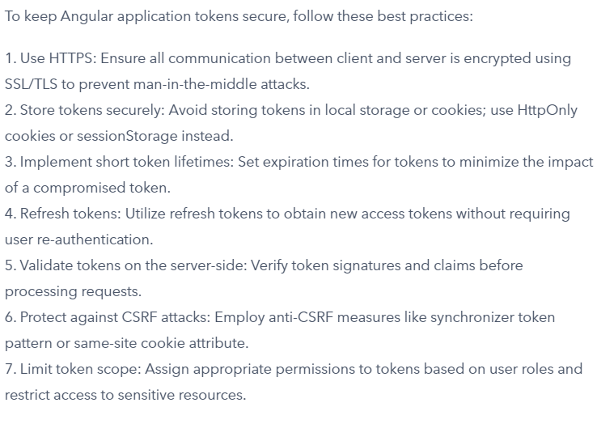C

#### JWT Token

## 

## Why is it called JWT Token?

#### 

#### 

#### 

#### 

#### 

#### 

#### 

#### 

#### 

#### 

#### 

#### Sessions vs JWT

#### 

#### 

#### 

#### Implement JWT token in .NET Core

#### <https://www.c-sharpcorner.com/blogs/jwt-authentication-in-asp-net-core-web-api>

#### 

### **1. Add ASP.Net Core API Application**

#### 

#### 

#### 

#### 

#### 

#### 

#### JWT token in .NET Core – step by step

#### Install JWT token package from Nuget

#### Add JWT token config in Program.cs / StartUp.cs

#### Add Authentication – add the authentication to web app

#### DefaultAuthenticateScheme & DefaultChallengeScheme – provides separate tokens to different users

#### Appsettings.json

#### When a token is created, it is based on key, the subject, Issuer & Audience

#### Add code for generating token

#### Claims - are key-value pairs that carry information about the token's subject (typically a user) and other relevant data. They are essentially pieces of information asserted about the token's subject.

#### Key – collect the private key from appsettings

#### signIn – capture the algorithm for creating the token key

#### token – generate the token based on Issuer, Audience, claims , expiration time and signIn algorithm

#### tokenValue – write token with tokenHandler

#### Program.cs / StartUp.cs

#### JWT Token Integration in Angular

#### Add the Service in Angular

#### Add the login method in component level

#### 

#### Create an interceptor for injecting the web token for other API calls

#### 

#### Declare Interceptor in the AppModule.ts

#### The interceptor will execute after the API is called from UI

#### Custom Authorization Filter

